

PARROT MATCH APPLICATION FOR ADOPTION

Thank you for considering adoption for one of our parrots. We are committed to finding the right home for each and every bird, and to providing you with the support and information necessary to create the best match possible. Our goal is to find the very best “landing” for every bird that comes to us, and that is why you are asked to provide the information in this application.

##### Benefits of our Process:

Rehoming as needed: If a placement doesn’t work out – no worries! We take responsibility for the parrot for life and we take full responsibility of the bird

The bird MUST come back to the rescue if it doesn’t work out.

Please give us reasonable notice

Please consider the questions on this application carefully. Complete every field, even if the answer is

“I don’t know.” We are all learning together to share our lives with these fascinating and challenging companions and no one has all of the answers.

##### The Adoption Steps

**Fill out this form and return it to North Tennessee Avian Rescue and Rehabilitation** at the following email: (Leigh) [**ephippium@yahoo.com**](mailto:ephippium@yahoo.com)

**Before completing this application . . .**

Parrots, when exhibiting natural behaviors, can be loud, destructive, and messy and require a tremendous amount of time and attention. To have a successful relationship, you must learn about the wild nature of parrots and be willing to make potential change in your home environment and your behavior. We are here to help, but parrot care is a big commitment. Consider how flexible your family is and whether a parrot is truly a good choice.

|  |  |
| --- | --- |
| **CONTACT INFORMATION:** |  |
| Your Name: |  |
| Street Address: |  |
| City, State, Zip |  |
| Phone Number(s): |  |
| Email Address: (please PRINT) |  |
| Date of Application: |  |

|  |  |
| --- | --- |
| How did you hear about us? |  |

|  |  |
| --- | --- |
| **RESIDENTIAL INFORMATION:** | Please answer all questions so we can make a great match for your family. |
| Do you rent or own? |  |
| If renting, does the landlord allow pets? |  |
| Single family home, apartment or townhouse? Would noise be an issue with your neighbors? |  |

|  |  |
| --- | --- |
| **FAMILY INFORMATION:** | Please answer all questions so we can make a great match for your family. |
| List family members and their ages. |  |
| How do the other family members feel about living with a parrot? |  |
| Are there smokers in the household? Does anyone have allergies that could be a problem? |  |
| Name and age of parrot’s primary caretaker: |  |
| List all other pets (dogs, cats, birds, exotics or other animals) in your home: |  |
| Type of parrot (parakeets, cockatiels and lovebirds are also parrots) that most interests you and why? |  |
| Has your family owned a parrot before? When and what species? |  |

|  |  |
| --- | --- |
| **DIETARY INFORMATION:** | Please answer all questions so we can make a great match for your family. |
| What is the best diet for a parrot? Please be specific. |  |

|  |  |
| --- | --- |
| **VET/HEALTH INFORMATION:** | Please answer all questions so we can make a great match for your family. |
| Do you already have an avian vet? Who is it? |  |
| If you have a parrot, when was his last appointment and what was it for? |  |
| Adopters, do you agree to take this parrot for regular check-ups with blood work? |  |
| If you have other parrots, do you understand the quarantine process and will your household accommodate separation of birds? |  |
| Are you aware that some cookware, plants and cleaning materials are toxic to birds? |  |

|  |  |
| --- | --- |
| **HOUSING INFORMATION:** | Please answer all questions so we can make a match for your family. |
| Describe the location of the parrot’s cage. What room will it be in? Where in the room will the cage be placed? What will the cage contain (perches, toys)? What other parrots will be in the same room? |  |
| Describe how much mobility the parrot will have. Will it leave its cage? Go to other rooms? Eat with the family?  Have a play gym? |  |
|  |  |

|  |  |
| --- | --- |
| Provide examples of how parrots are different than other pets, and what you can do to meet these needs? |  |

Include any other information you consider important for us to know, so that we can work together to help each parrot find the best new

home:

I look forward to working together to make a better life for a parrot-in-need. By signing this application you indicate that you understand the adoption process and agree to comply with it.

Thank you:)

Leigh Furman Founder and Director of NETARR (423) 742-2423

Signature Date

We believe that all parrots deserve the largest cage possible. Round cages are never appropriate for any parrot.Parrots should only be housed in environments that give them lots of room for flapping and foraging; room for a wide variety of perches (cloth, wood, rope, etc.); multiple feed dishes to encourage activity and natural foraging instincts; and bar spacing that is an appropriate size.

They also deserve and need plenty of time outside the cage.

|  |  |
| --- | --- |
| ⬥ Parakeet, Cockatiel, Lovebird, | 27w x 24d |
| ⬥ Ringneck, Conure, Pionus, Meyers, Quaker, Lories and Lorikeets, Senegal, multiple small birds | 32w x 23d |
| ⬥ African Grey, Amazon, Caique, HawkHead, Eclectus, Goffins Cockatoo, Bare-Eyed Cockatoo, Lesser or Medium Sulphur Cockatoo, Citron Cockatoo, Cape, Jardines | 36w x 28d |
| ⬥ Umbrella Cockatoo, Greater Sulphur Cockatoo, Triton Cockatoo, Rose-Breasted Cockatoo, Mollucan Cockatoo, Military Macaw, Scarlet Macaw, Blue and Gold Macaw  ⬥ Greenwing or Hyacinth Macaw | 40w x 30d 48w x 36d |

Do’s and Dont’s of Parrot Ownership The Do’s

DO concentrate on good behavior.

DO give your birds a bath with water only or mist with a spray bottle at least 2 to 3 times a week. DO feed a wide variety of fresh fruits and veggies.

DO feed and replace with fresh food daily and provide clean water at all times daily.

DO clean and change the bottom of the cage daily. Scrape off any poop or organic material daily and wash and disinfect the cage weekly with a bird safe product.

DO provide toys (8-10 is preferable) and rotate toys at least once a week.

DO be sure your bird(s) has plenty of stimulating destructible and non-destructible toys to attack and chew.

DO play directly and give your bird attention daily. Birds need at least 10 to 12 hours of sleep in a quiet dark room.

DO give protein, in the form of cooked meat or scrambled, hard-boiled eggs at least once a week but no more than 3 times a week.

DO remember that your bird(s) are intelligent. You need to interact with them and teach them. DO treat your bird like it is an intelligent 3 to 4-year-old human, you’ll get better results.

DO be persistent and consistent with rules and boundaries.

DO walk away, turn your back and act insulted by bad behavior. With good behavior is even more enthusiastic than usual during this training period to help develop your own habits. Your voice should be higher and a bit louder when praising and low and snarl when noting bad behavior.

DO be patient, training takes time and there are no quick fixes for long-term results. DO ask questions. The only stupid question is one that is never asked.

DO read as much, on your bird, as you possibly can.

DO research online, with other bird owners, your vet, and behaviorists but do it with an open mind and think completely over what you are going to try to do before doing it.

DO teach your bird to be handled by others.

DO teach your bird the command to step up and step down.

DO travel with your bird in a safe carrier if you must travel with your bird at all.

DO make sure your vet is a licensed avian vet and have his or her phone number posted by the phone in case of an emergency arises.

DO make sure that your bird sees an avian vet at least once a year for a checkup. DO keep the bird(s) toenails, wings trimmed and beak trim, for their own safety.

DO give your bird playtime away from its cage every day.

DO sanitize all new toys, cages, bowls, and perches before giving them to your bird!

DO provide a cage that has more than ample space for the bird(s) to move around and flap its wings or buy the largest cage you can afford.

DO remember your bird(s) are your companion for life. Take responsibility for your bird(s) seriously, they do depend on you to take care of them.

DO keep a close watch on your bird(s) with children, strangers, and other animals and do not leave your bird unsupervised.

DO remember that your bird(s) are as comfortable with people as people are with them. DO inspect toys every day for frayed rope, sharp objects, broken pieces and etc.

DO use FILTERED water

The Dont’s

Don’t concentrate on bad behavior. If you cannot address bad behavior immediately then don’t address it at all.

Don’t reward bad behavior with treats, no treats should be given at least 20 minutes after bad behavior. Don’t use water or physical hitting as punishment.

Don’t place toys in the middle or in the front of the door opening.

Don’t during the winter skip misting, humidity is very important to tropical birds and when you run your heater in your home it dries out the air. (same with air conditioner)

Don’t take your bird outside unprotected or leave your bird outside unobserved.

Don’t take your bird outside without its wings trimmed and inside a carrier, cage or on a flight leash. All it takes is a gust of wind, something to spook or scare the bird one time to take off. The wind current can still carry a bird, even though its wings are clipped and if a bird gets to a tree the instinct is to climb to the top of the tree.

Don’t leave the toilet seat up if you are going to allow your bird to fly free in your home; they can’t swim and will drown.

Don’t use sandpaper perch covers, grit, gravel or gravel paper. Grit is not necessary for parrots and can cause impaction of the digestive systems.

Don’t use moth protectors, mite or lice spray anywhere that your bird can come in contact with them; they are TOXIC!

Don’t smoke around your bird(s). Nicotine is deadly to birds. Not only does 2nd hand Smoke harm them, but you need to wash your hands very well because it comes through the pores of the skin of smokers’ hands and can cause the bird(s) to have a severe contact reaction or even death.

Don’t cook with the bird on your shoulder or have the bird loose in the kitchen. This can be very dangerous.

Do not use Febreeze products in any areas of the home that the bird will be able to touch – it is toxic to birds.

Do not use any type of scented oils or heated scented oils in areas around the birds – this is also toxic. Do not have lit candles around your birds unless they are soy candles. These are the only candles that are safe around birds.

Do not use Teflon or any kind of coatings on your pans. Teflon, etc. overheated will cause death in birds. Don’t buy toys with dog leash type clips or jingle bells. This is an injury waiting to happen. Toes can get caught very easily in these.

Don’t have toys that have small rings that the bird(s) can put their heads through. They may choke and die, from trying to get their heads back out.

Don’t use “S” hooks with birds that have strong beaks. They can open these up and do some serious harm to them, they can even cause death.

Don’t use litter made of walnut shells or corncobs. It can cause life-threatening Impaction if ingested by birds. They also harbor fungal spores when soiled or wet. Newspaper is much safer.

Don’t apply kwik-stop or other styptic products to avian skin. They are safe for bleeding toenails when broken or cut too short, but they destroy the skin. For broken or pulled blood feathers, either cornstarch or flour is safe. Aloe gel can be applied first to help the flour or cornstarch adhere to the wound and to help with pain and healing.

Don’t use lead, zinc, copper, and iron. They can cause metal toxicities if ingested by birds. Some sources are house keys, (especially gold colored keys), galvanized wire, and lead-based paints, metallic paints, paint containing zinc, linoleum, vinyl mini-blinds, foil from champagne and wine bottles, lead

weights, and bells with lead clappers, stained glass, some improperly glazed ceramics, costume jewelry, mirror backing, copper pennies, zinc oxide, artist paints containing cadmium, and cardboard or paper with high gloss inks. Aviary wire treated with zinc is also dangerous.

Don’t handle or touch a bird if you or know somebody who is having chemotherapy treatments. The radiation can be transferred thru the bird’s skin and can be deadly.



Banks ,a Bech Blr,ch Bottlebrush **Cit us** -

(Ume, kumquat,. grape_rul. orange, 1emo1n) crab appl1e crep1e myrtie Dog ood Eucalyp

# Fig F1-

Gr,a1pe:vine Gr1ev llea Guava

HII rsc, _S I1iron ba1rk LHaic

L lly IP'lillly

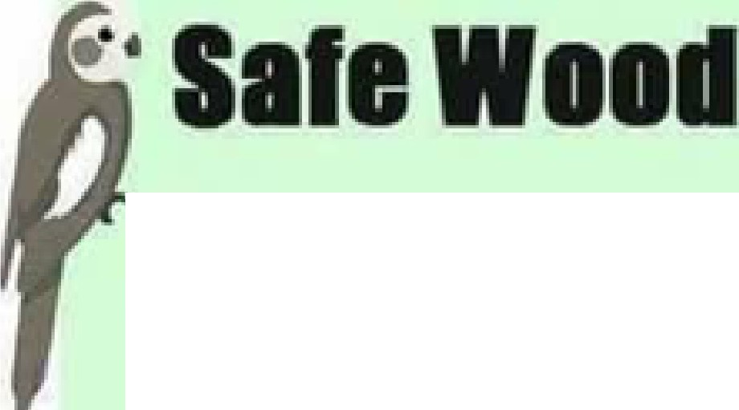

* Almond Apple Ash e.amboo

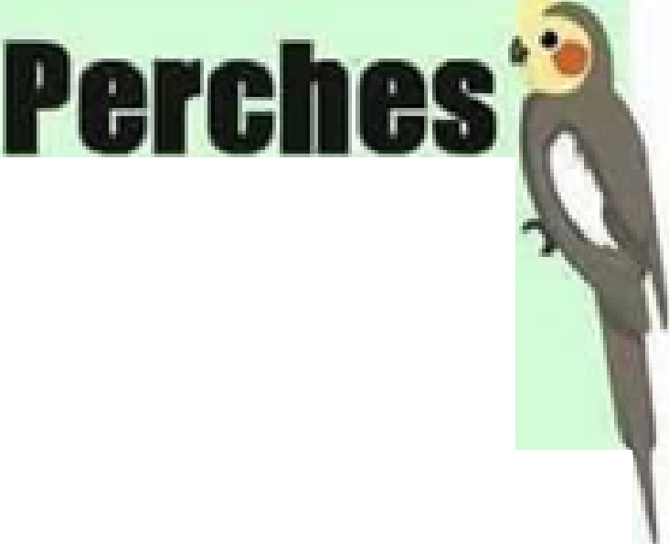

# Magnolla (avo d C!h nese ma1gnolla)

Manza1nlta Map,le

Me aleuca

MeSiqulte (remove thorns)

Mlm·osa Paille verde Pa1penba •k Pecan

P n1e•(.avold pItch p1ilne) Rose (remo,ve-horns) Vlburn1m

.attle

WIid M s:tang Grapes WII o (Goat, IP'ussy & wee,1ing)

No,te: 'This,Us is not ,comp:reh.enstv:e. The list nas been complied ba,s don _comendaJons by dn ins and 1fcrum m -biers.

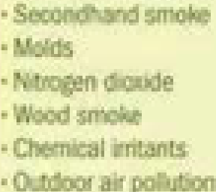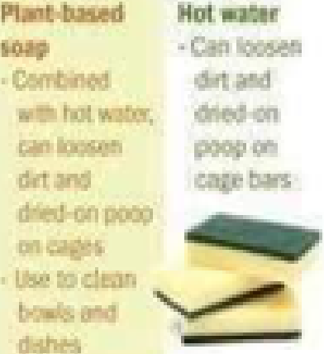

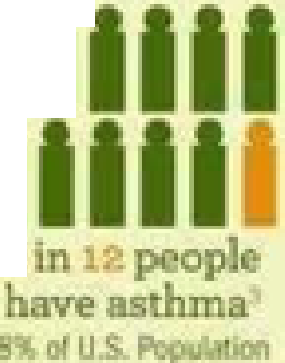

**II'**

I

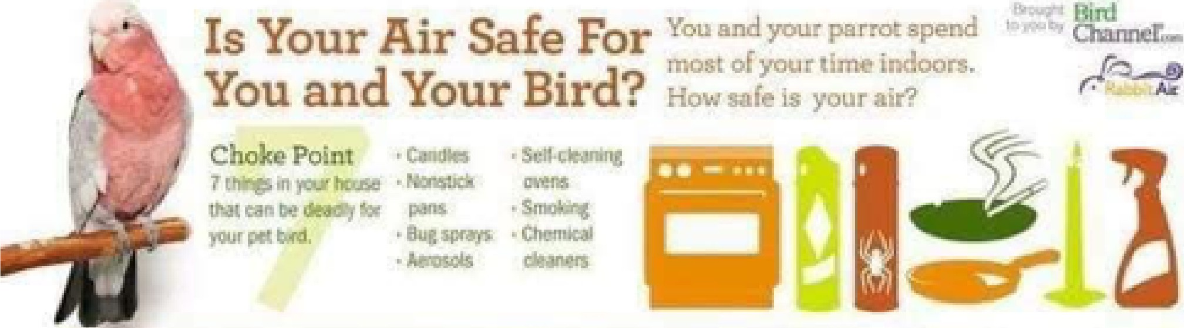

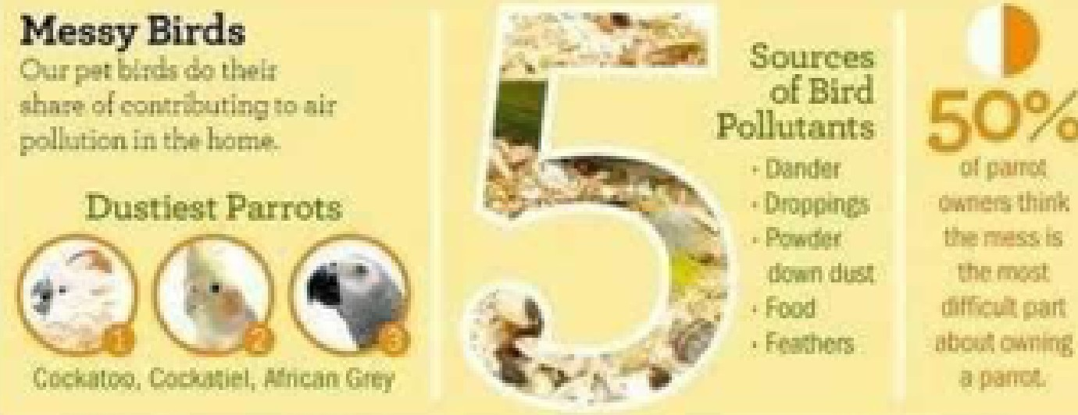AD FOR THEM

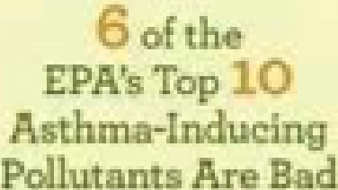BAD **FOR.YOU**

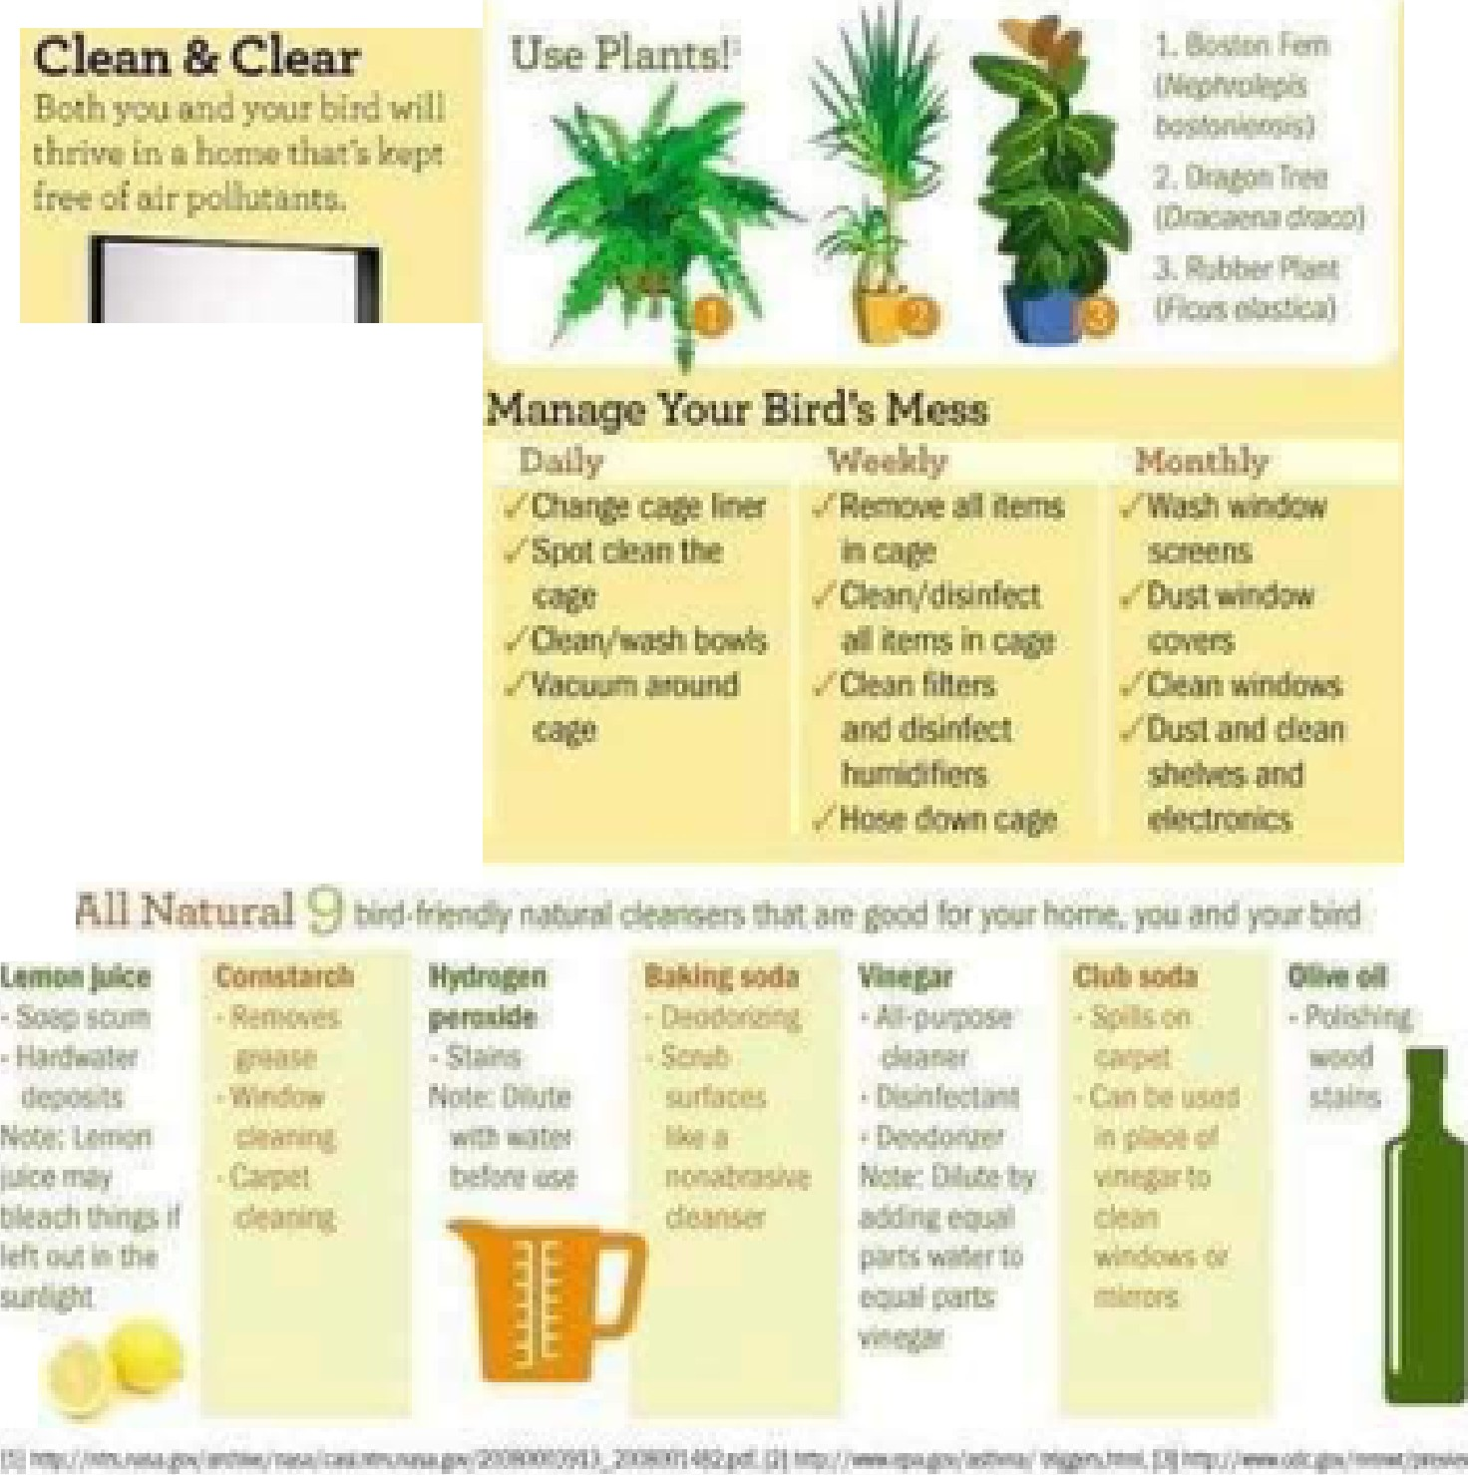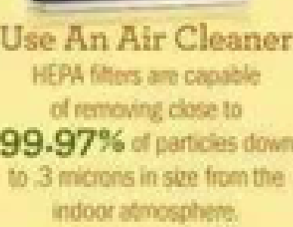

for Your **B[rd Tc,o**

i'

Go

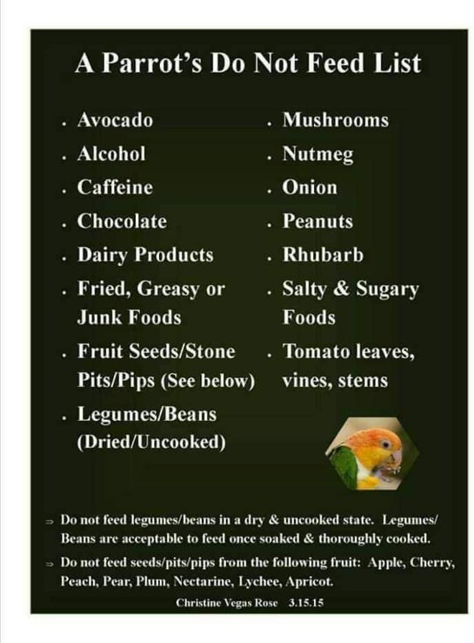

  



**Fm.it**

**(PicL:: one or** t )

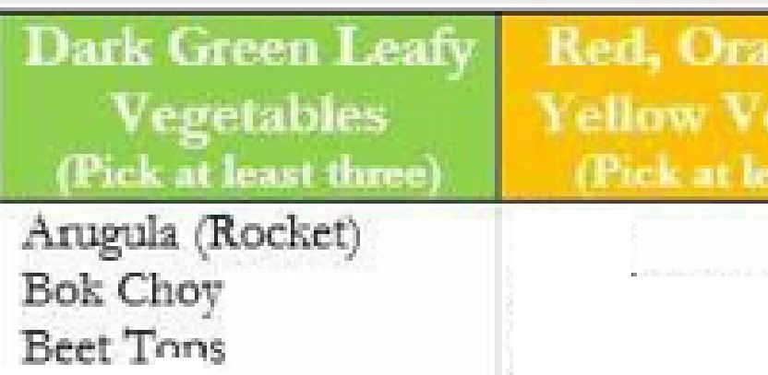

B- ts

B pp s

..

Btoccc­

·Bio- oli - b **/Rap·**-­

B:tu,s s Spi'O

.J. ' -,0 p

Curots

l? • 'p. *:* . (fi:" '

*r*i:'ti"I '

P'cbl *·.o*·pep-p



on

- - an

Cilantro



. -- .

]3

**'B '-lil;i;ll,tl !L-1, ,.;**



Caulifio iChnd (Sil·;accceet) CollaJ:d Gf(:cn Dm.d&on.GtffilS Kalt

l.Imwd G.!i:e -::n-s.

Olwl RollW11.C **TlLWlip GtcC1"5**

W:iLtH1C'J[• s

**b**

hd.Cabbag·

## Summru:Sqw.sh

### ·'p

Wmter, , s.m (A.co Buttemu. :K.-i!boch.a.,, Spagltc *e:tc)* tPq,pm

t Po to: (coo --

#### Zooclliw

Chari

Crmbuii

## Dngo:n. Fmit.

Kn'1;i

n&ngo

#### P: aja P ch Pmi:iapplre Plum

**P-D'm**

#### Oungc

Star Fm.it

0 *o*

.

#### Roscmarr

Thyme=

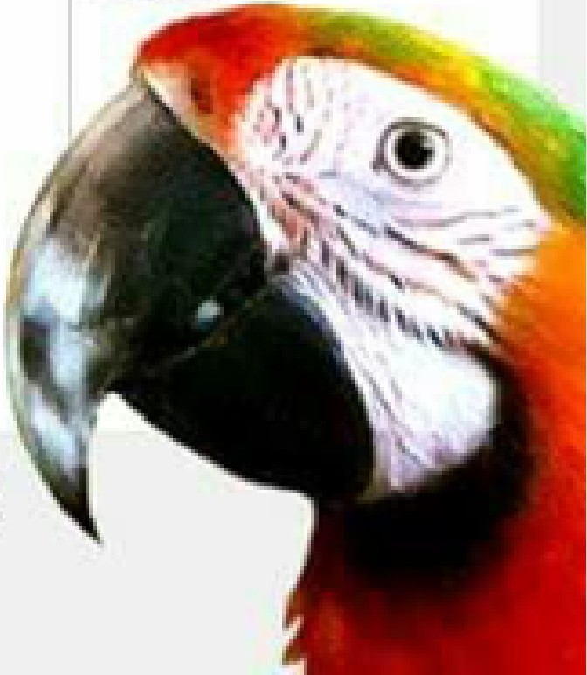R-m•-_m'b ,11-·.·.YO - 10:Yof. ruit



-

**5,QOJ'**

, •-be fed in conj • 1ctian rith 4D - pe

|  |  |  |  |  |
| --- | --- | --- | --- | --- |
|  | **r** _ II | ·. • | h | * id |
| ofyoe.r |  |  | * - |
| *i*  **t** | li |  |  | I  -· |

**10**

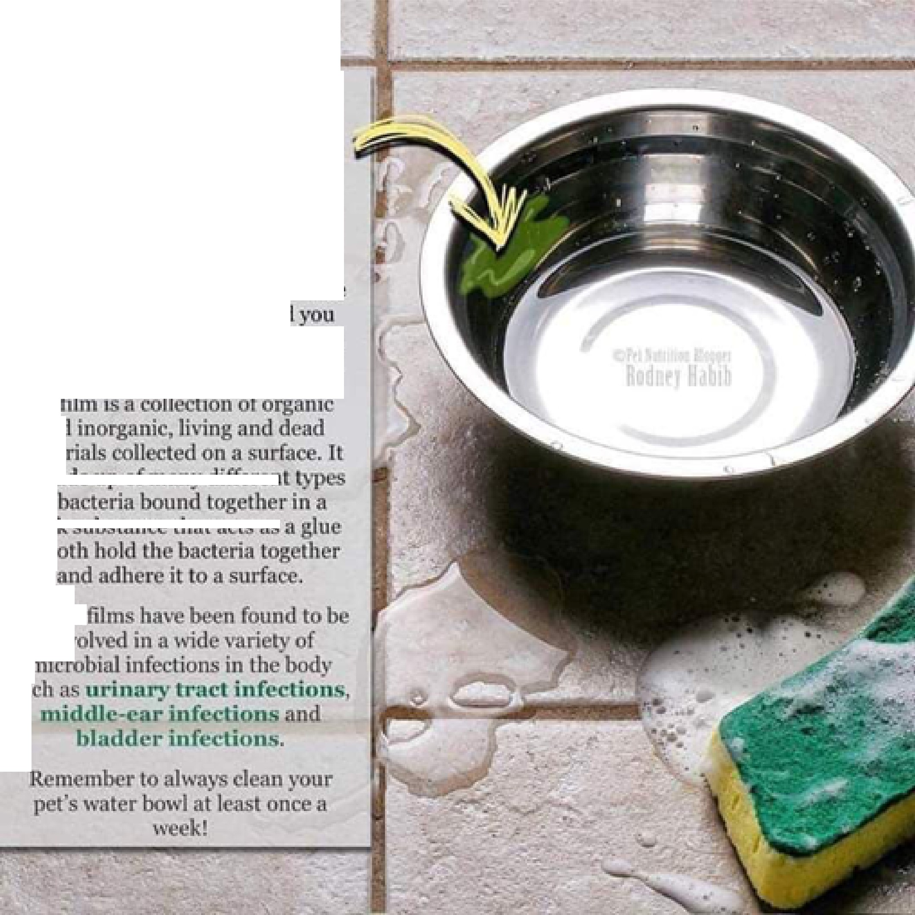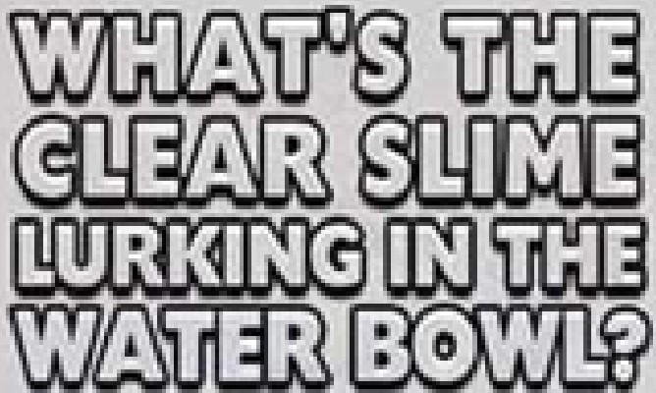

;j,IQ(

### m te

[ **ffl** I

of

### tbic •

0

## B io

llJI\

I

Iii

